Getting Started

# avoCADo

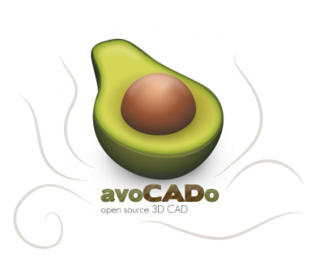

//Hey, there was login prblems on the avoCADo wiki that made me unable to edit so I decided to create a getting //started guide instead. It is in early drafts so please provide feedback and edit the document as desired.

avoCADo (often written avoCADo-CAD to distinguish it from the fruit) is an Open Source 3D CAD design/modelling program written under the GPL. It is an attempt to offer a real alternative to commercial mechanical CAD and 3D modelling software. Many Open Source CAD programs have been developed over the years, but all seem to fall short in some form or another. By starting from a solid foundation and allowing for rapid expansion of both functionality and collaboration via plug-ins, avoCADo aims to be an indispensable tool with an intuitive interface for both engineers and artists alike.

The key elements of avoCADo will be:

* Simple 3D object design environment
* Expandable plug-in framework (tools, conversion, elements, materials, etc.)
* Collaboration and sharing with others
* Integrated part library support
* XML based open file formats
* Careful attention to usability
* Minimal restrictions to creative thinking

// copied and pasted from the avocado blog, please replace this with a description relevant to the context of a //user guide

# Installing and Running avoCADo

## Linux/Linux64

* If you don’t already have Java 1.6 or later, download and install it
* Download avoCADo from [SourceForge](https://sourceforge.net/project/platformdownload.php?group_id=187405) and unzip it
* Open the unzipped folder
* Double click the "avoCADo" file to run the program or open the command line and type:

./avoCADo

* If you cannot execute the file, you may need to change its permission first. Type this before running avoCADo

chmod a+x avoCADo

* If you have multiple versions of Java, you may need to call to the current version of Java directly. Assuming Java installation is in: "/usr/java/jdk1.6.0", open the command line, navigate to the avoCADo directory and type:

/usr/java/jdk1.6.0/bin/java -Djava.library.path=libs/SWT/:libs/JOGL/lib/ -jar avoCADo.jar

## Mac

* If you don’t already have Java 1.6 or later, download and install it
* Download avoCADo from [SourceForge](https://sourceforge.net/project/platformdownload.php?group_id=187405) and unzip it
* Open the unzipped folder

## Windows

* If you don’t already have Java 1.6 or later, download and install it
* Download avoCADo from [SourceForge](https://sourceforge.net/project/platformdownload.php?group_id=187405) and unzip it
* Open the unzipped folder
* Double-click on "avoCADo.bat"

# The avoCADo User Interface

The avoCADo user interface was designed to make the designing and modelling process to be an extremely intuitive process. By eliminating most of the explicit navigation commands and relegating modelling commands to only one invocation option, the user interface is able to be more user-friendly and uncluttered. The user is directed through the work environment mostly by implicit navigation invocations by avoCADo; consequently once the user has a bearing on the cues in the user interface he is able to navigate more efficiently than previously because he no longer needs to invoke manual commands to traverse the avoCADo workbenches. //I don’t know, i made that shit up :))

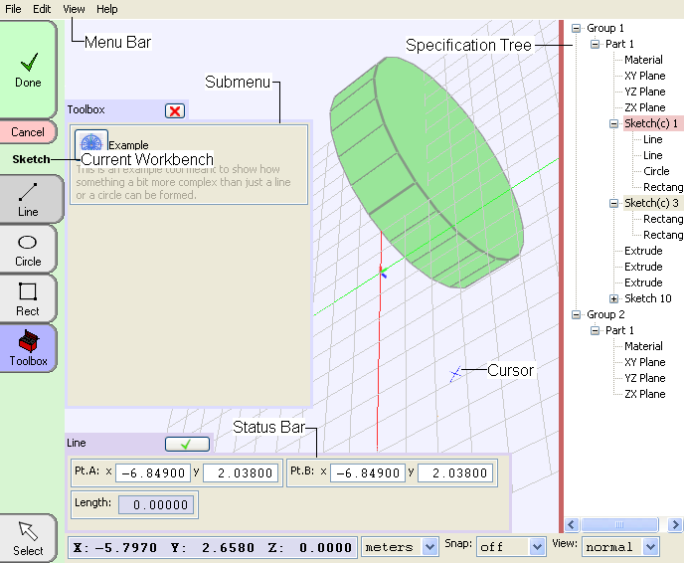

The avoCADo commands are divided into workbenches. Each workbench is a clear subdivision of each stage of the modelling process. During each stage of the modelling process the respective workbench has the commands the user needs to complete the stage in one invocation of the workbench. /\* do we call them workbenches \*/

Please take note of the labels describing the user interface above as they will be used throughout this guide.

## The Sketch Workbench

All feature defining entities created in avoCADo are created using sketches. The sketch is the foundation of all solid based features. The sketch workbench is open by default whenever avoCADo is started but it can be invoked explicitly by creating a new sketch, double clicking an existing sketch in the specification tree or can be directly invoked by the sketch icon in the part workbench.

## The Build Workbench

This workbench manipulates features made in the sketch workbench into solid geometry. This is the only way to create the base solids for a part. The build workbench can only be explicitly invoked by clicking the build icon in the part workbench.

## The Modify Workbench

This workbench is used to modify features created in the build workbench. This would include standard features that would not need to be based upon a sketch, for example a fillet. This workbench can only be explicitly invoked using the modify icon in the part workbench.

## The Part Workbench

This workbench serves as a junction for the sketch, build and modify workbenches. Inside it and its sub-ordinate workbenches includes all the functions that are needed to define all the characteristics of a particular part in an assembly. It can be directly invocated from the group workbench or by double clicking an existing part in the specification tree.

## The Group Workbench

This workbench

## The Project Workbench

This workbench is

# Navigating 3D Space

The navigation of the graphics window is achieved using the following 3 commands.

## Rotate

Hold Mouse Wheel

Press Ctrl + Hold mouse wheel

Press ↑ or ↓ or ← or →

Press Ctrl + ← or →

The rotate command spins the part in the graphics window around 3D space. To invoke this command either hold the mouse wheel down and move the mouse around or use the arrow keys on your keyboard. To rotate the part around an axis that extends laterally in the graphics window, hold the control key while rotating the part.

## Pan

Press Shift + Scroll mouse wheel

Press Shift + ↑ or ↓ or ← or →

The pan commands move the

## Zoom

Scroll mouse wheel

Press Ctrl + ↑ or ↓

//Cant think of shit to say about this

# Creating 2D Geometry

## Drawing Points

→ICON!!!



Click the point icon from the sketch workbench. To draw points, click anywhere in the graphics window. A dot in the graphics window will denote where you have placed the point.

You can also place points by entering horizontal and vertical coordinate positions. First create a point and the status bar will expand. You can then input the X and Y locations in their respective input fields in the status bar.

## Drawing Lines

E:\avoCADo-08.03-preAlpha-Windows\icons\menuet\Part_Sketch.png → **E:\avoCADo-08.03-preAlpha-Windows\icons\menuet\2D_Line.png**

Click the line icon from the sketch workbench. To draw lines, click anywhere in the graphics window and while holding the mouse button place the mouse cursor at the location of where the line should end and then release the mouse button. A line entity will be created.

You can also create lines by entering horizontal and vertical coordinate positions for each line end point. First create a line and the status bar will expand. You can then input the X and Y locations for each end point of the line in their respective input fields in the status bar.

## Drawing Rectangles

E:\avoCADo-08.03-preAlpha-Windows\icons\menuet\Part_Sketch.png →E:\avoCADo-08.03-preAlpha-Windows\icons\menuet\2D_Rect.png

Click the rectangle icon from the sketch workbench. To draw rectangles, click anywhere in the graphics window and while holding the mouse button place the mouse cursor at the location of where the opposite corner of the rectangle should be and then release the mouse button. A rectangle will be created.

You can also create rectangles by entering two horizontal and vertical coordinate positions for each opposite corner. First create a rectangle and the status bar will expand. You can then input the X and Y location for each opposite cornet in their respective input fields in the status bar.

## Drawing Circles

E:\avoCADo-08.03-preAlpha-Windows\icons\menuet\Part_Sketch.png →E:\avoCADo-08.03-preAlpha-Windows\icons\menuet\2D_Circle.png

Click the circle icon from the sketch workbench. To draw a circle, click anywhere in the graphics window to specify its center, while holding the mouse button release it at a point on its circumference that will specify its diameter.

You can also draw a circle using the by inputting coordinates, first create a circle and specify the X and Y locations of its center and a point on its circumference by using the status bar.

## Drawing Arcs

E:\avoCADo-08.03-preAlpha-Windows\icons\menuet\Part_Sketch.png →E:\avoCADo-08.03-preAlpha-Windows\icons\menuet\2D_Arc.png

Click the arc icon from the sketch workbench. To draw an arc, click anywhere in the graphics window to specify the center point of the arc. Click on a second point in the graphics window to specify the radius and start point of the arc, then click on a third point to define the end point.

Alternatively you can create arcs defined by points inputted by the keyboard. To do that first create an arc, then in the expanded status bar edit the X and Y coordinate values for each point to be modified.

## Drawing Ellipses

E:\avoCADo-08.03-preAlpha-Windows\icons\menuet\Part_Sketch.png →ICON!!!

Click the ellipse icon from the sketch workbench. To draw an ellipse, click anywhere in the graphics window to specify its center. Click on a second point in the graphics window to specify the major axis and the orientation of the ellipse, and then click on a third location to specify a point on the ellipses circumference.

Alternatively you can create ellipses defined by points inputted on the keyboard. To do that first create an ellipse, then in the expanded status bar edit the X and Y coordinate values for each point to be modified.

# Tutorial: Creating 2D Geometry

# Editing 2D Geometry

## Selecting and Modifying 2D Geometry

E:\avoCADo-08.03-preAlpha-Windows\icons\menuet\Part_Sketch.png →E:\avoCADo-08.03-preAlpha-Windows\icons\menuet\Select.png

Click the select icon from the sketch workbench. To select geometry, click anywhere on any part of the sketched entity you want to select. The selected entity will turn orange and the status bar expands to show input fields to modify the selected entity.

To modify the selected entity, In this expanded status bar you can edit the coordinate geometry used to construct the selected entity.

## Deleting 2D Geometry

E:\avoCADo-08.03-preAlpha-Windows\icons\menuet\Part_Sketch.png → **E:\avoCADo-08.03-preAlpha-Windows\icons\menuet\Toolbox.png** →ICON!!!

rgahrhsrhrersth

## Trimming 2D Geometry

E:\avoCADo-08.03-preAlpha-Windows\icons\menuet\Part_Sketch.png → **E:\avoCADo-08.03-preAlpha-Windows\icons\menuet\Toolbox.png** →ICON!!!

## Extend 2D Geometry

E:\avoCADo-08.03-preAlpha-Windows\icons\menuet\Part_Sketch.png → **E:\avoCADo-08.03-preAlpha-Windows\icons\menuet\Toolbox.png** →ICON!!!

## Filleting 2D Geometry

E:\avoCADo-08.03-preAlpha-Windows\icons\menuet\Part_Sketch.png →E:\avoCADo-08.03-preAlpha-Windows\icons\menuet\Toolbox.png →E:\avoCADo-08.03-preAlpha-Windows\icons\menuet\2D_Fillet.png

## Chamfering 2D Geometry

E:\avoCADo-08.03-preAlpha-Windows\icons\menuet\Part_Sketch.png → **E:\avoCADo-08.03-preAlpha-Windows\icons\menuet\Toolbox.png** →ICON!!!

## Mirroring 2D Geometry

E:\avoCADo-08.03-preAlpha-Windows\icons\menuet\Part_Sketch.png → **E:\avoCADo-08.03-preAlpha-Windows\icons\menuet\Toolbox.png** →ICON!!!

## Offsetting 2D Geometry

E:\avoCADo-08.03-preAlpha-Windows\icons\menuet\Part_Sketch.png → **E:\avoCADo-08.03-preAlpha-Windows\icons\menuet\Toolbox.png** →ICON!!!

## Array/Pattern

E:\avoCADo-08.03-preAlpha-Windows\icons\menuet\Part_Sketch.png → **E:\avoCADo-08.03-preAlpha-Windows\icons\menuet\Toolbox.png** →ICON!!!

## Linear array/Pattern

E:\avoCADo-08.03-preAlpha-Windows\icons\menuet\Part_Sketch.png → **E:\avoCADo-08.03-preAlpha-Windows\icons\menuet\Toolbox.png** →ICON!!!

## Polar array/Circular pattern

E:\avoCADo-08.03-preAlpha-Windows\icons\menuet\Part_Sketch.png → **E:\avoCADo-08.03-preAlpha-Windows\icons\menuet\Toolbox.png** →ICON!!!

# Tutorial: Editing 2D Geometry

# Constraining 2D Geometry

## Adding Dimensional Constraints

E:\avoCADo-08.03-preAlpha-Windows\icons\menuet\Part_Sketch.png → **E:\avoCADo-08.03-preAlpha-Windows\icons\menuet\Toolbox.png** →ICON!!!

## Modifying Dimensional Constraints

E:\avoCADo-08.03-preAlpha-Windows\icons\menuet\Part_Sketch.png → **E:\avoCADo-08.03-preAlpha-Windows\icons\menuet\Toolbox.png** →ICON!!!

# Tutorial: Constraining 2D Geometry

# Creating 3D Geometry

## Align/Mate

→ICON!!!



## Boolean

E:\avoCADo-08.03-preAlpha-Windows\icons\menuet\Part_Build.png →ICON!!!

## Intersect

E:\avoCADo-08.03-preAlpha-Windows\icons\menuet\Part_Build.png →ICON!!!

## Subtract

E:\avoCADo-08.03-preAlpha-Windows\icons\menuet\Part_Build.png →ICON!!!

## Union

E:\avoCADo-08.03-preAlpha-Windows\icons\menuet\Part_Build.png →ICON!!!

## Extrude

E:\avoCADo-08.03-preAlpha-Windows\icons\menuet\Part_Build.png → **E:\avoCADo-08.03-preAlpha-Windows\icons\menuet\2D3D_Extrude.png**

## Loft

E:\avoCADo-08.03-preAlpha-Windows\icons\menuet\Part_Build.png → ICON!!!

## Revolve

→ E:\avoCADo-08.03-preAlpha-Windows\icons\menuet\2D3D_Revolve.png



## Rib

E:\avoCADo-08.03-preAlpha-Windows\icons\menuet\Part_Build.png →ICON!!!

## Shell

E:\avoCADo-08.03-preAlpha-Windows\icons\menuet\Part_Build.png →ICON!!!

## Sweep

E:\avoCADo-08.03-preAlpha-Windows\icons\menuet\Part_Build.png →ICON!!!

# Tutorial: Creating 3D Geometry

# Editing 3D Geometry

## Mirror

→ICON!!!



## Chamfer

→ICON!!!



## Fillet

→ICON!!!



# Tutorial: Editing 3D Geometry

# Creating Sketches from Existing Features

Creating Sketch from Existing Face

Creating Sketch

# NOTES

// Because avoCADo is an incomplete product I can only write this documentation under the extrapolations of what I believe it will look like in future revisions. All non-existent features of avoCADo mentioned in this manual are mentioned under the ergonomics of what I believe is the most intuitive strategy of invoking those features.